**python- deploy flask app**

starting point of our application is main.py file.

list of dependencies documented in requirements.txt file

to install all the dependencies ---> pip install -r requirements.txt

after that run python main.py

default flask port 5000 --- flask can only run in development server to deploy flask in production we have to use some tools those are GUnicorn, uWSGI, Gevent, Twisted Web

to run application in GUnicorn

---> gunicorn main:app [app- flask app component which we mentioned in the mian.py file]

Gunicorn will host a server that listens for – 8000 –default port

To spawn to multiple workers we have use –w option

Gunicorn main: app –w 2

**Node js- Deploy express app**

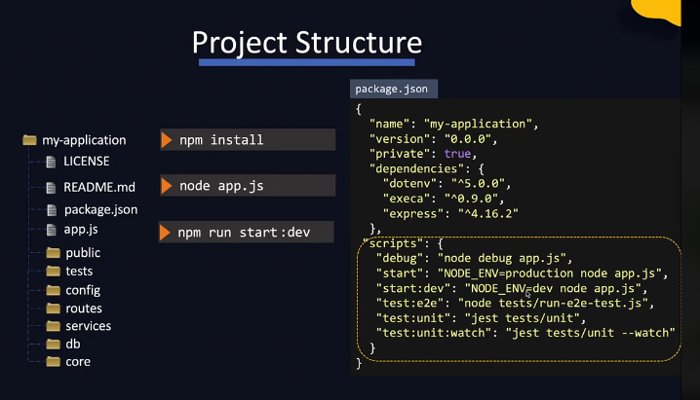

Readme.md -🡪 instructions to run the file

Package.json -🡪 meta data of the application eith dependencies

App.js 🡪 usually starting of the application

Public directory -🡪 which has front end file such as html, css, java script

Tests directory 🡪 which has some automated tests

Config directory 🡪 to store configurations of the file

Routes 🡪 to define different api routes

Service directory 🡪 to store external services implementation

Db directory 🡪 to store database models and seed files

Core directory 🡪 to store core business logic

It listens to the port 3000

Pre defined scripts that will help you to run applications with different settings in different environments such as dev database in development environment or with different settings in production environment all are mentioned under scripts section in package.json file

To run particular command in script section 🡪 npm run start:dev

* If the application was crashed node will simply shutdown, preventing access to the application for other users and that’s were other tools like supervisord, forever, pm2
* Pm2 is a production grade process manager for nodejs with built in load balancer.

--- Pm2 start app.js

For starting multiple instances in a cluster mode

* Pm2 start app.js – i 4

Here Number of process you want to run -4 – automatically run four instances of our application

pm2 scale your_app 8 🡪 to increase instances size

pm2 list 🡪 to see running instances

npm install -g pm2 -🡪 to install pm2 globally

loopback interface – 127.0.0.1/18 🡪 default host for all the systems

with in your host, if you wish to test your application you can simply open up a browser and type in 127.0.0.1 :8000 the port which it will listen too

we also try like this localhost:8000

every host has different internal loop back interface with the same ip address of 127.0.0.1